IMPORT JOURNAL ENTRIES  
FROM EXCEL SPREADSHEET  
(G-U-1)

To Start, the journal entry must be set up in excel as below.

Row 1 and 2 are just explaining what fields and in what order the journal has to be set up.

The first line of the journal is the information in the header of the journal, (posting date and whether the journal is a reversing journal). Enter YES for recurring or NO if not a recurring journal. You must have an H in the second column to identify this as the header line. The header line must appear before the line items or “T” lines.

The following lines under that are for the actual journal entries. First column is your unique identifying number, the second column is to identify that it is the line item, “T” line, the 3rd column is the general ledger account number, the 4th column is for the Description for the line and the final column is for the amount or trailer amount.

Those first 2 rows must be deleted after setting up excel journal entry, as shown on second screen below.

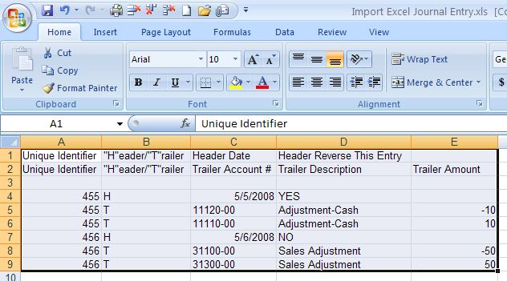

Above screen must be shown as below without the header names when finished and before importing

into Advanced Software as shown below.

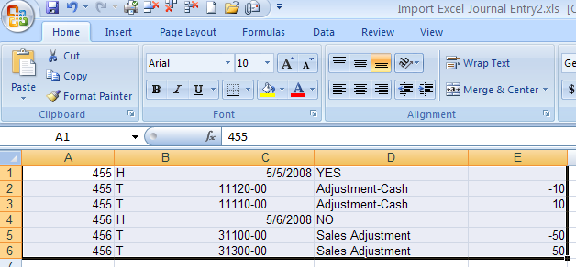

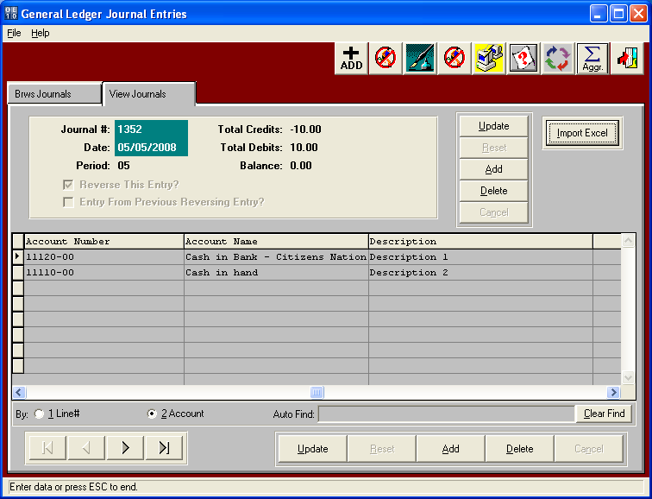

To begin importing a journal entry from an excel spreadsheet, you must open GU1 (Enter/Edit Journal Entries) on the General Ledger menu.

Click on the Import Excel button on the journal entry screen shown above.

Type in the location of the excel file to import or browse to find.

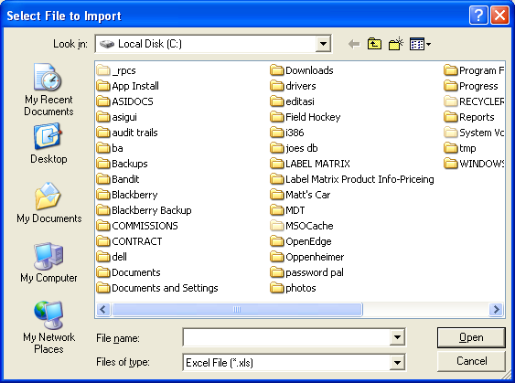

Below is showing that when importing the file into Advanced Software, it created two journals, one for each posting date. As you can see the first journal was marked as a reversing entry.

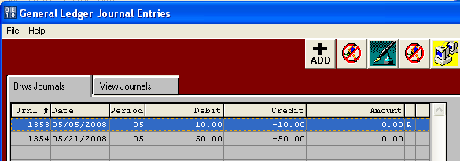

You can now post these entries using G-U-2.